Nama : Asri Nihal Salsabila

NIM : 18090087

Kelas : 5C

1. URL : <http://localhost/web2/index.php/perkenalan>
2. Source Code

application 🡪 controller 🡪 perkenalan.php

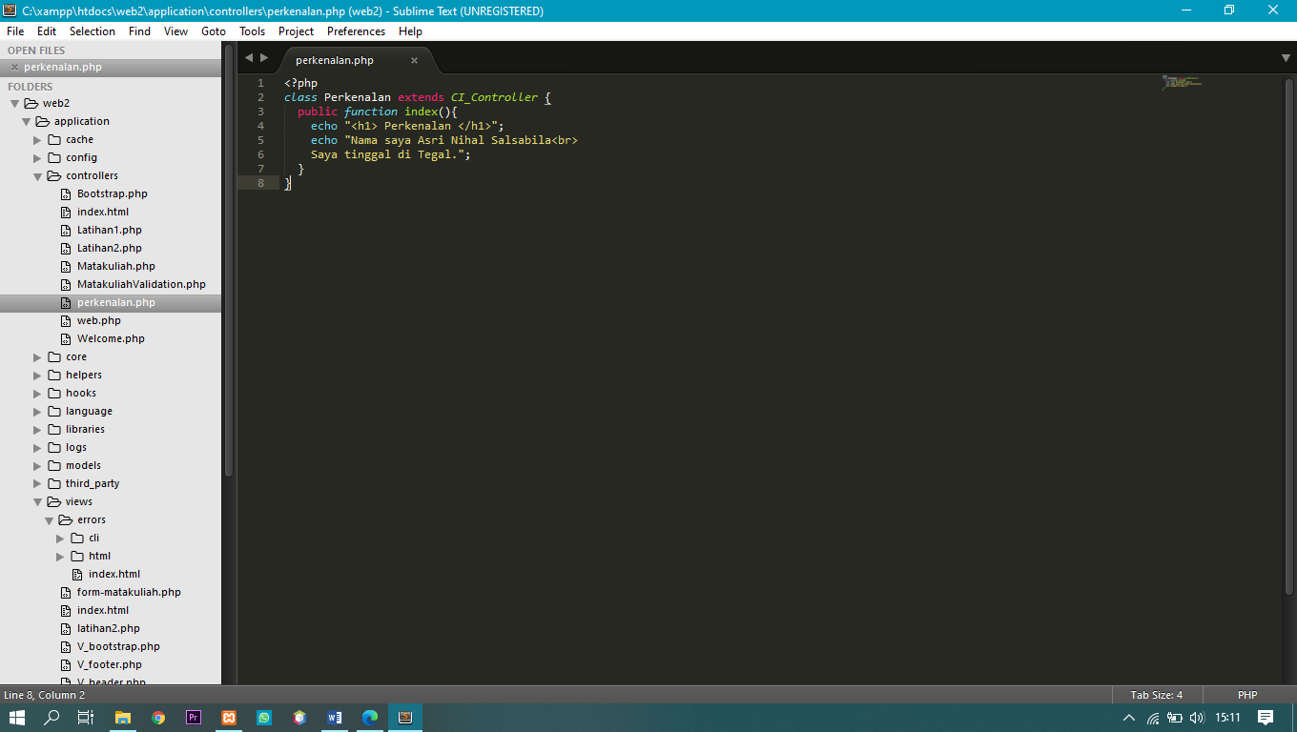

1. Screen Shoot

